Section 13.4 – Home Ownership math 1010

Using a Table to find a Monthly Mortgage Payment

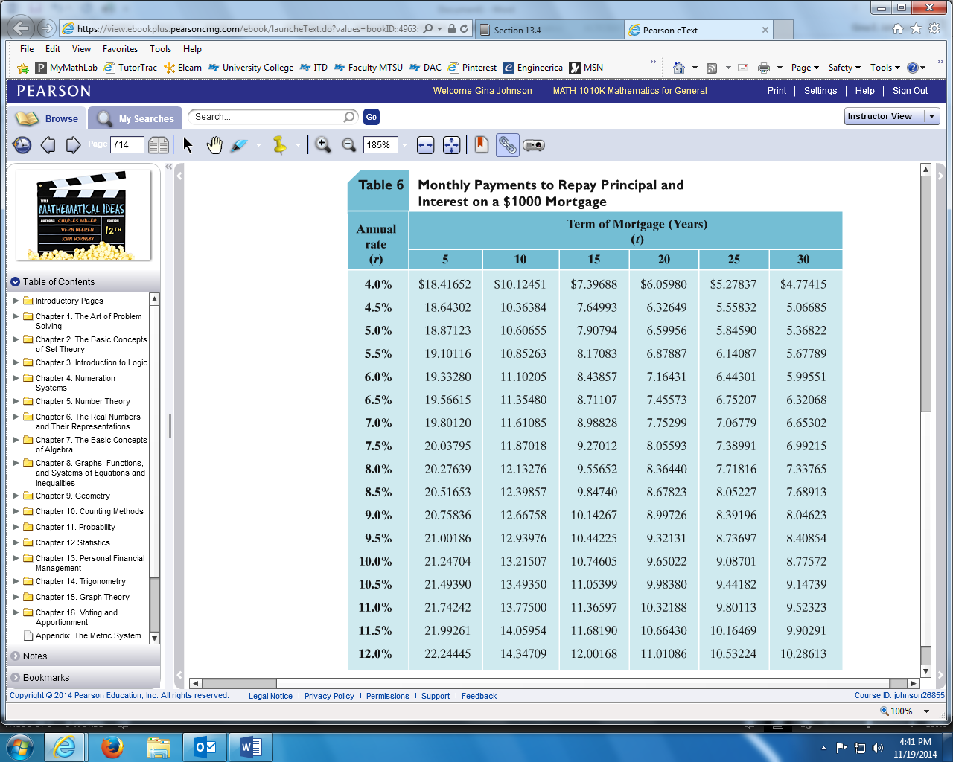

**EXAMPLE:** Find the monthly payment necessary to amortize $98,000 at 6.5% for 25 years.

In the table above, read down to the row for 6.5% then read across to the column for 25 years. What is that entry number? ________________

This number is the monthly payment amount needed to amortize a lone for $1000. The money amount being amortized is based on increments of $1000.

How many $1000 are we financing for? _______________________________

Multiply these two number together to find the monthly payment:

**EXAMPLE:** Find the monthly payment needed to amortize the principle and interest for each fix-rate mortgage using the chart.

|  |  |  |  |
| --- | --- | --- | --- |
| **Loan Amount** | **Interest Rate** | **Term** | **Monthly Payment** |
| $70,000 | 10.0% | 20 years |  |
| $50,000 | 11.0% | 15 years |  |
| $205,000 | 5.5$ | 10 years |  |

Section 13.5 – Financial Investments math 1010

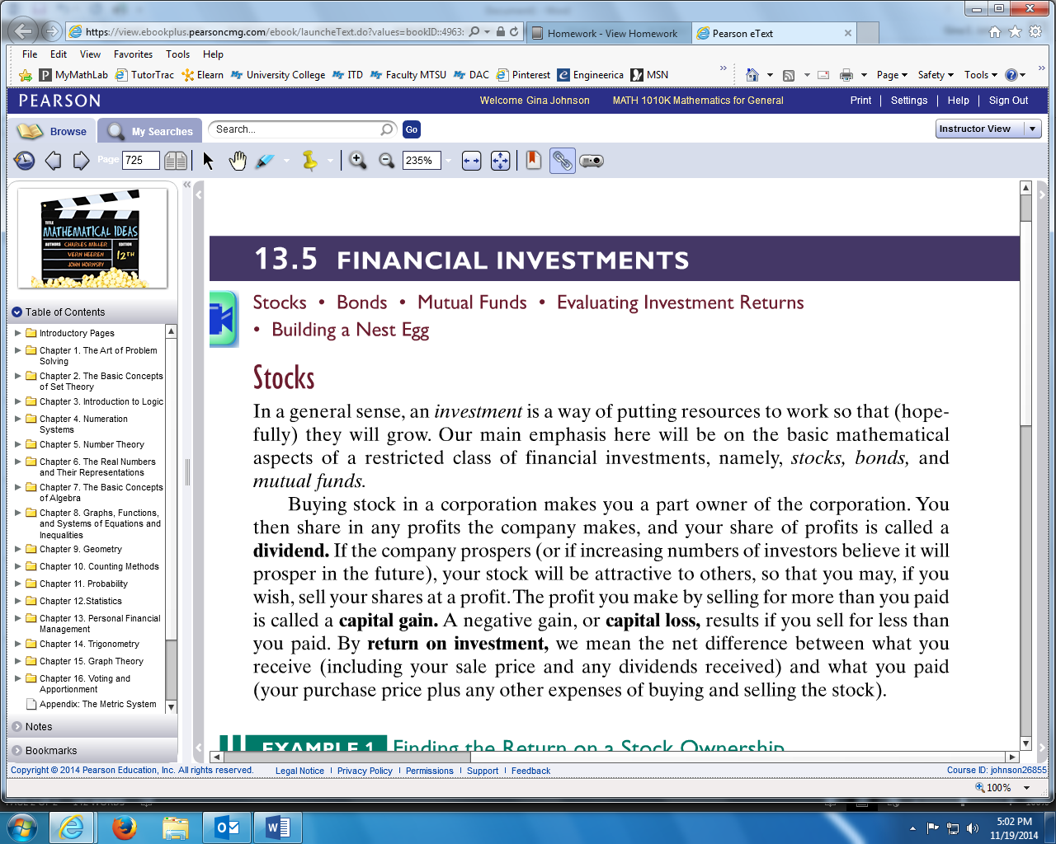

**EXAMPLE:** Lauren bought 100 shares of stock in a company on January 15, 2010 paying $30 per share. On January 15, 2011, she received a dividend of $0.50 per share and the stock price had risen to $30.85 per share. Find the following:

1. What was Lauren’s **total cost** for the stock?
2. What was the total **dividend**?
3. What was Lauren’s **capital gain** if she sold her stock in 2011?
4. What was Lauren’s **total return** on her one year investment?
5. What was Lauren’s **percentage return** on her investment?